 

**The British College**

**Kathmandu**

**Advance web engineering**

**Name: Ravi Prakash Yadav**

**ID: 77298004**

# 

Table of Contents

Introduction 3

Introduction to Hospital Management System (HSM) 3

Key Features: 3

Conclusion 4

Version control 5

Part 1 7

Version control 7

Interface before login 8

Login page 8

Register page 9

Validation check 9

Authentication check 10

User interface after login 11

Booking appointments before and after login 11

My appointment 12

Contact us form 13

About-us 13

Logout section 14

Interface 14

Our doctors with pagination 15

Interface 15

Starts with adding a doctor 16

Appointment with sort by functionality 16

All doctors with search functionality 17

Update doctor features 17

Code show 18

Controllers 21

Code from the home controller 27

Database 30

Doctor table 30

# Introduction

# ****Introduction to Hospital Management System (HSM)****

Welcome to the Hospital Management System (HSM), a comprehensive and user-friendly platform designed to streamline healthcare operations, enhance patient experiences, and facilitate efficient management within a medical facility.

## ****Key Features:****

1. **User-Friendly Interface:** HSM provides an intuitive and user-friendly interface, ensuring seamless navigation for both patients and administrators.
2. **Appointment Booking:** Patients can effortlessly book appointments, either as registered users or guests, choosing their preferred doctor, date, and time for consultation.
3. **Personalized Patient Profiles:** Registered users enjoy personalized profiles, allowing them to track their appointment history, view appointment statuses, and receive notifications.
4. **Doctor Management:** Admins have the power to manage doctors efficiently. They can add new doctors, update their information, and remove outdated entries to maintain an up-to-date database.
5. **Appointment Approval Workflow:** After patients book appointments, administrators can review and approve requests. Approved appointments trigger notifications, ensuring patients are informed promptly.
6. **Notification System:** Patients receive real-time notifications about appointment approvals, cancellations, and other updates, keeping them informed and engaged.
7. **About Us Section:** Learn more about the hospital through the "About Us" section, providing insights into the institution's mission, vision, and commitment to healthcare excellence.
8. **Contact Information:** Easily reach out to the hospital with the provided contact information. Whether it's for inquiries, feedback, or emergencies, the contact section ensures smooth communication.
9. **Secure Authentication:** Prioritize security with a robust authentication system. Registered users can log in securely, ensuring their personal health information is confidential.
10. **Logout Functionality:** Users can securely log out of their accounts, providing an additional layer of data protection.

Conclusion**:**

Hospital Management System (HSM) is not just a platform; it's a dynamic solution catering to the evolving needs of modern healthcare. Whether you are a patient seeking convenient appointments or an administrator managing the intricacies of a medical facility, HSM is designed to deliver efficiency, transparency, and a superior healthcare experience for all.

Experience the future of healthcare management with HSM - where technology meets compassionate patient care.

# Version control

GitHub link: https://github.com/tbc-bsc-l6/component-2-raviroyy

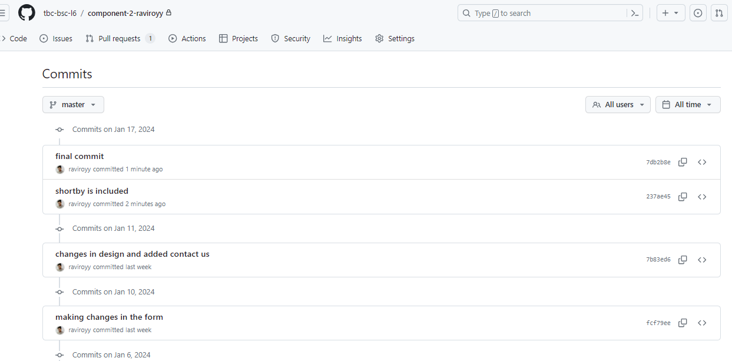

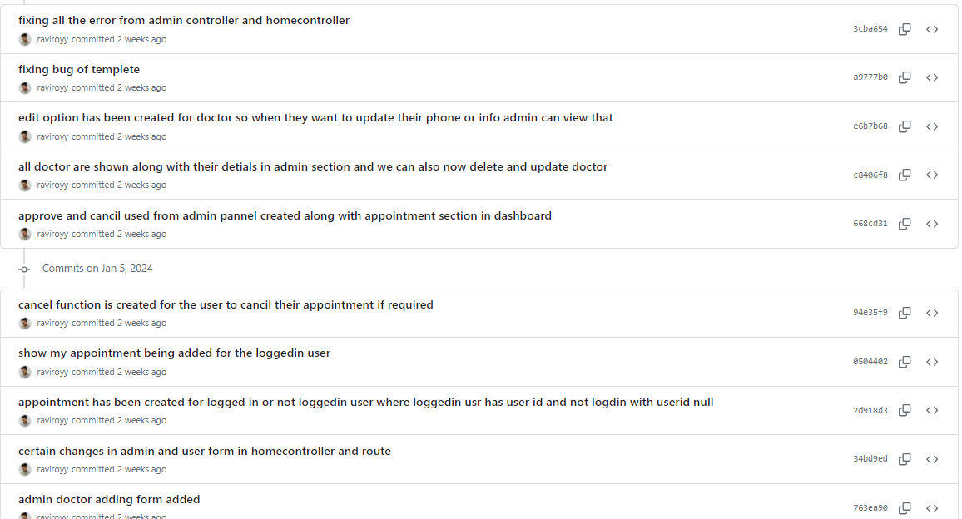

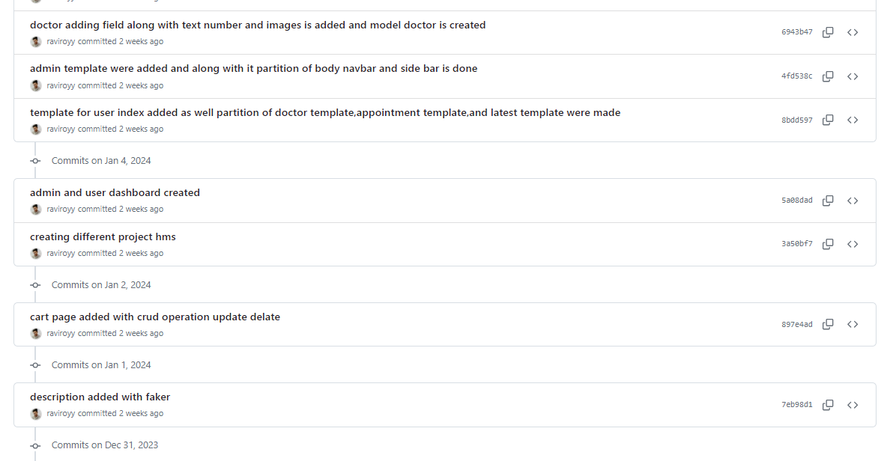

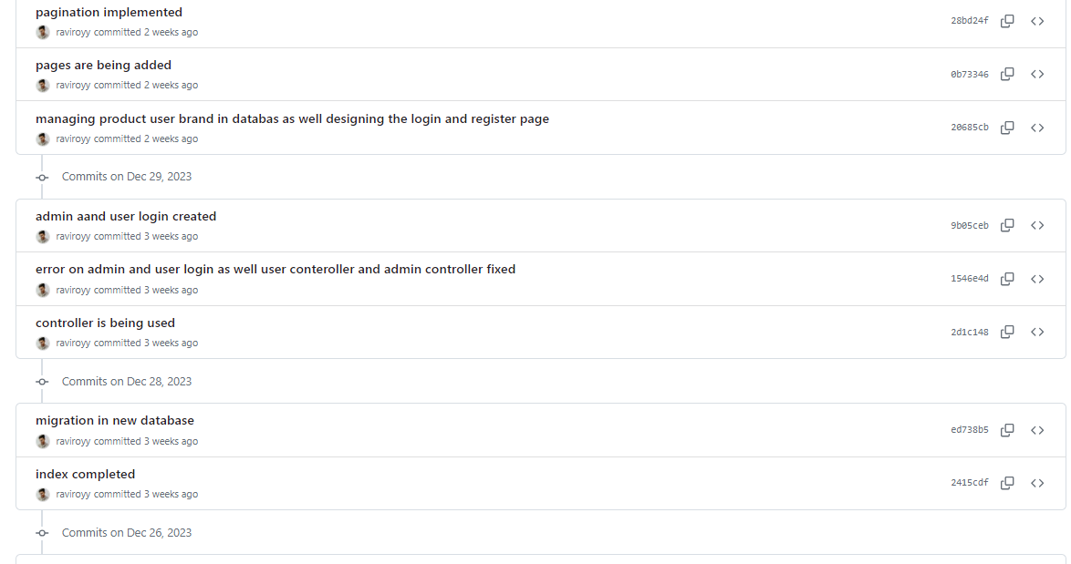

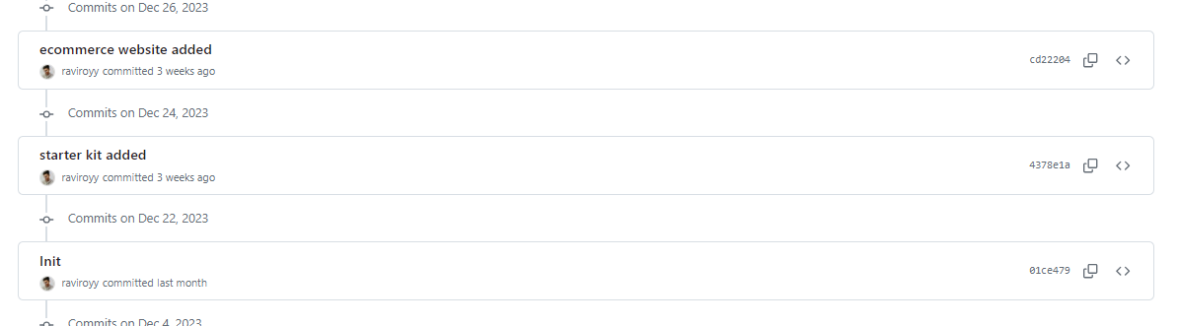

## Part 1

## Version control

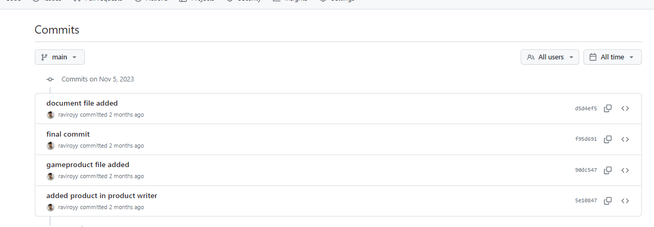

## Interface before login

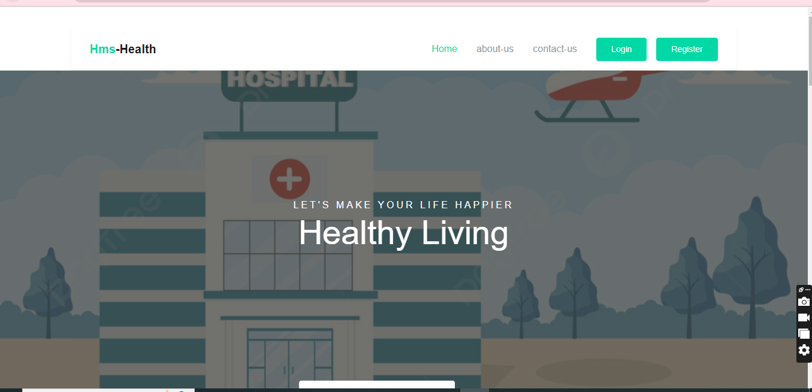

## Login page

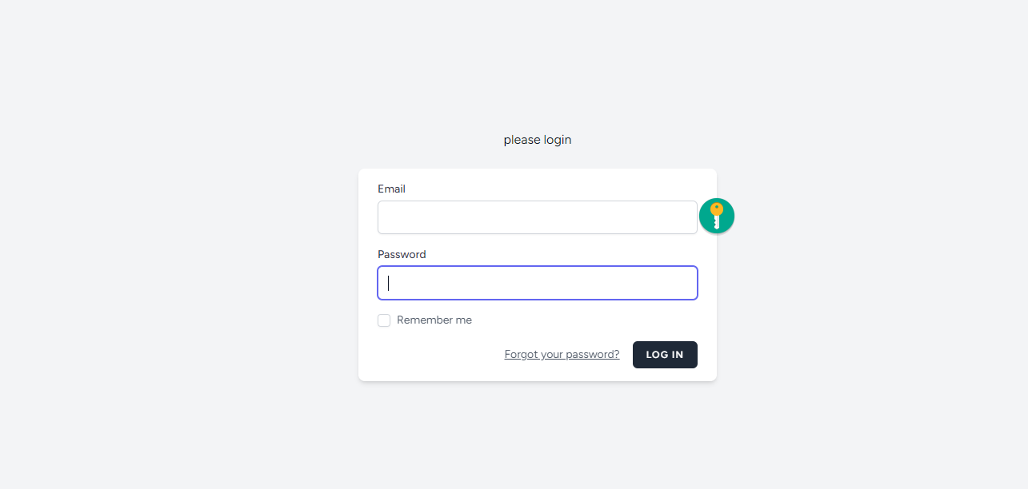

## Register page

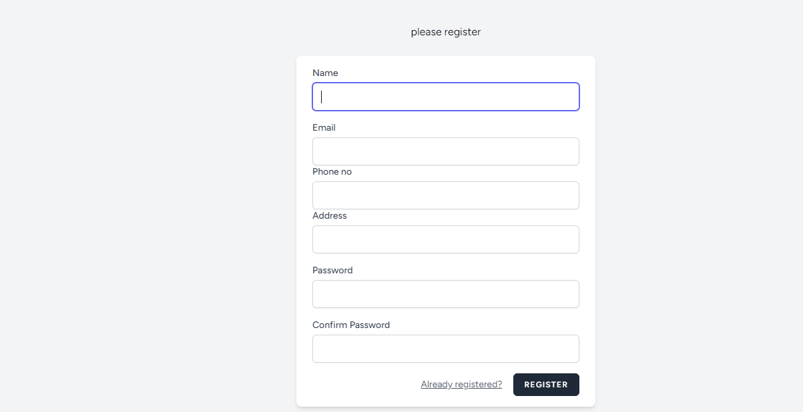

## Validation check

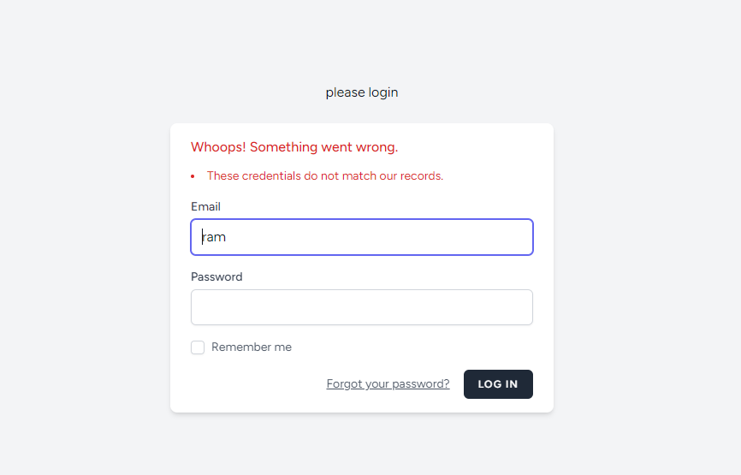

## Authentication check

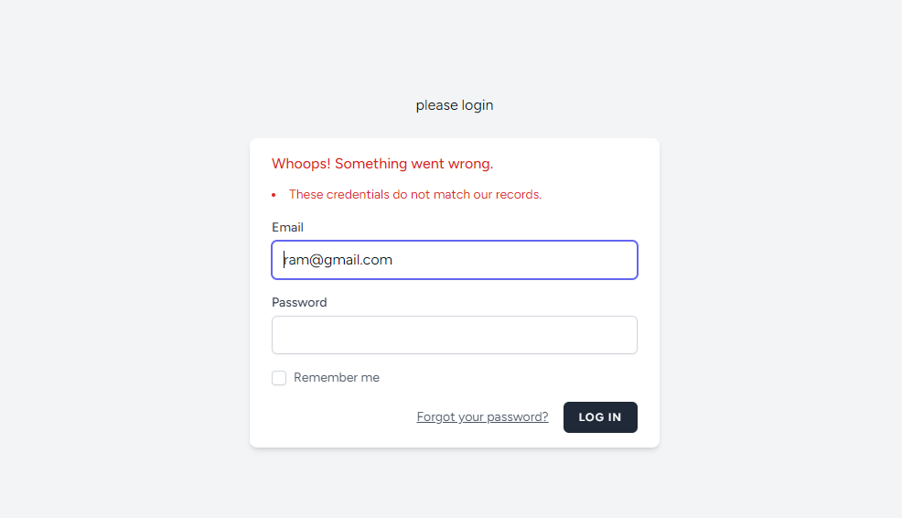

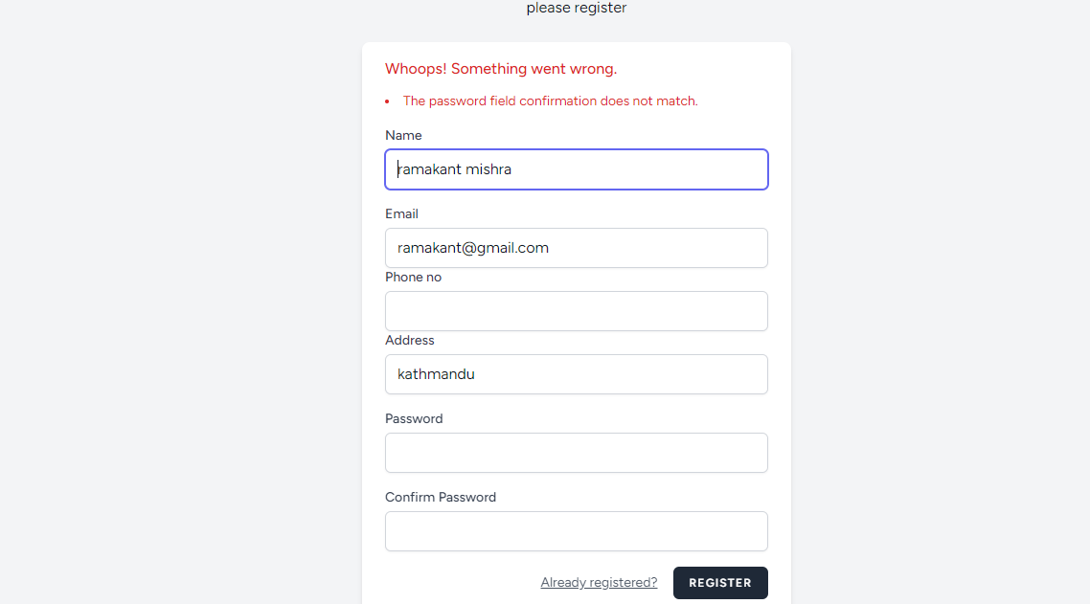

## User interface after login

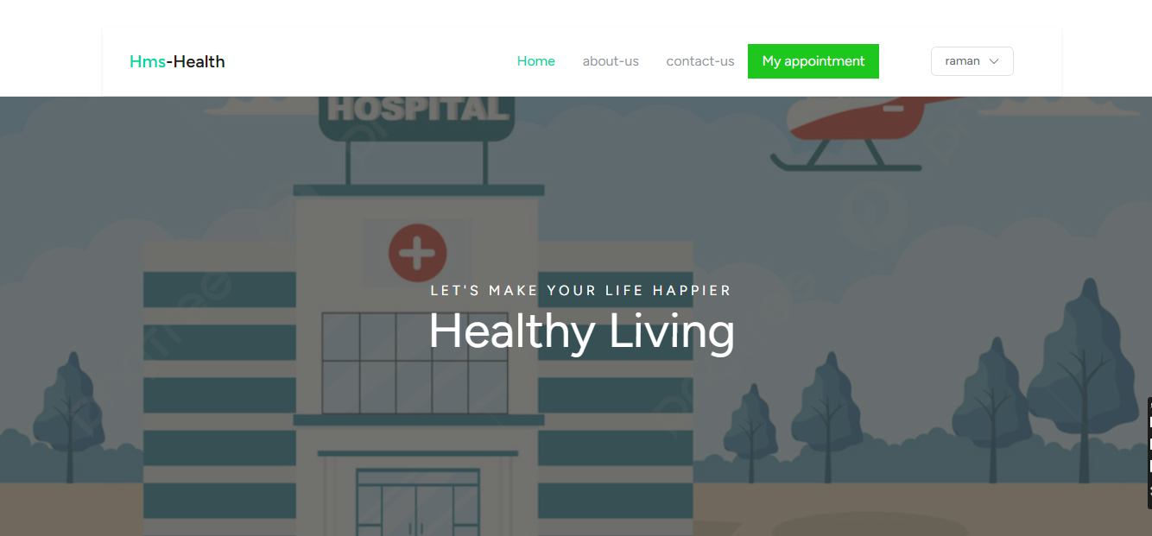

## Booking appointments before and after login

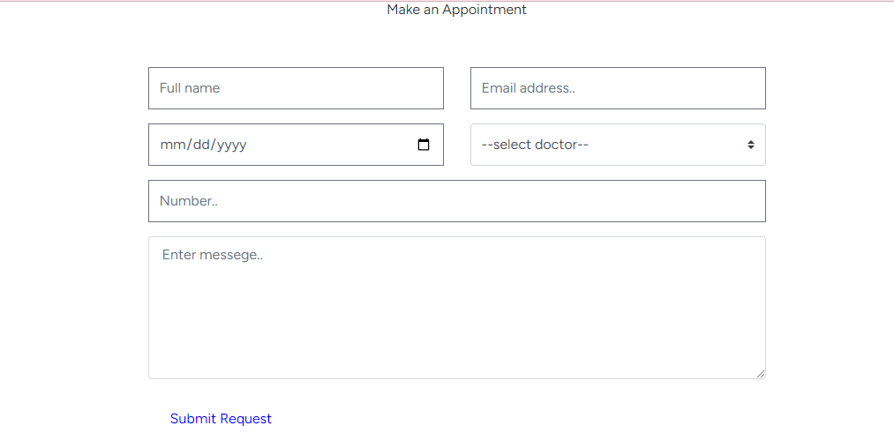

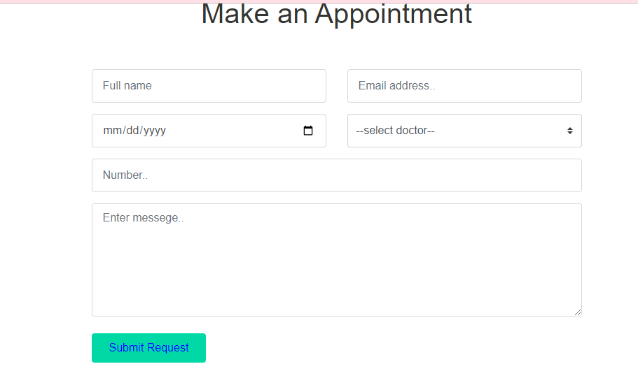

## My appointment

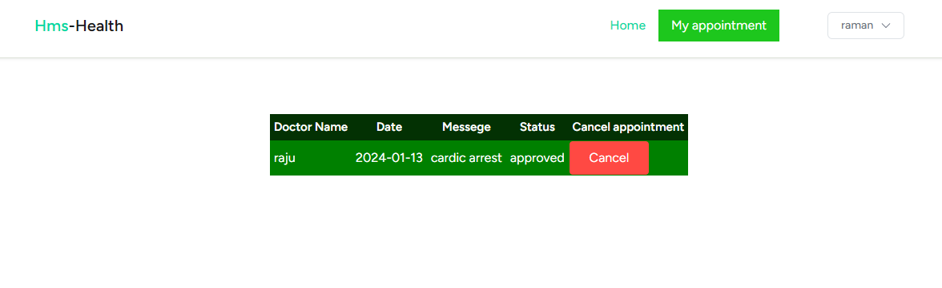

## Contact us form

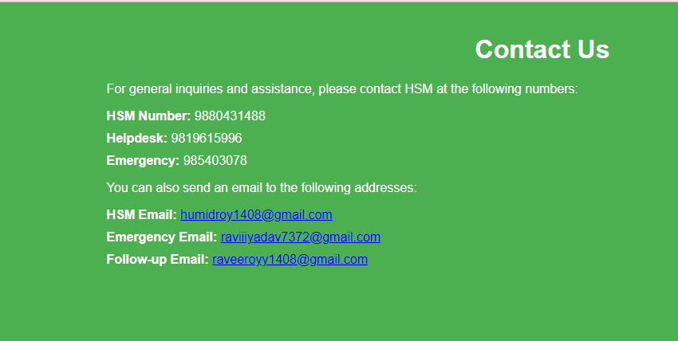

## About-us

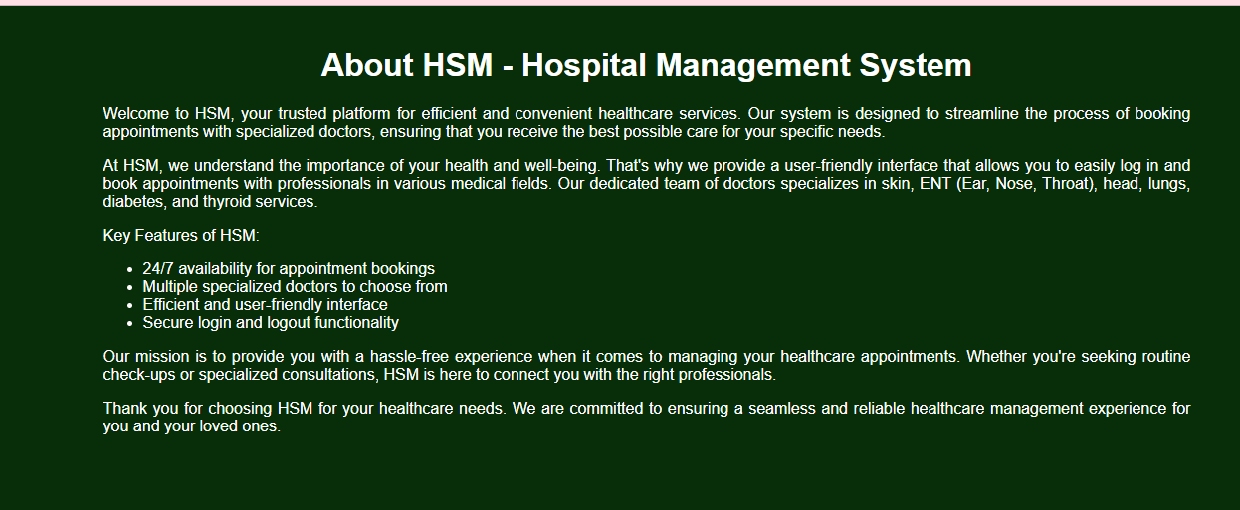

## Logout section

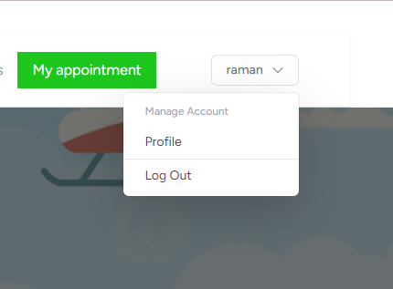

## Interface

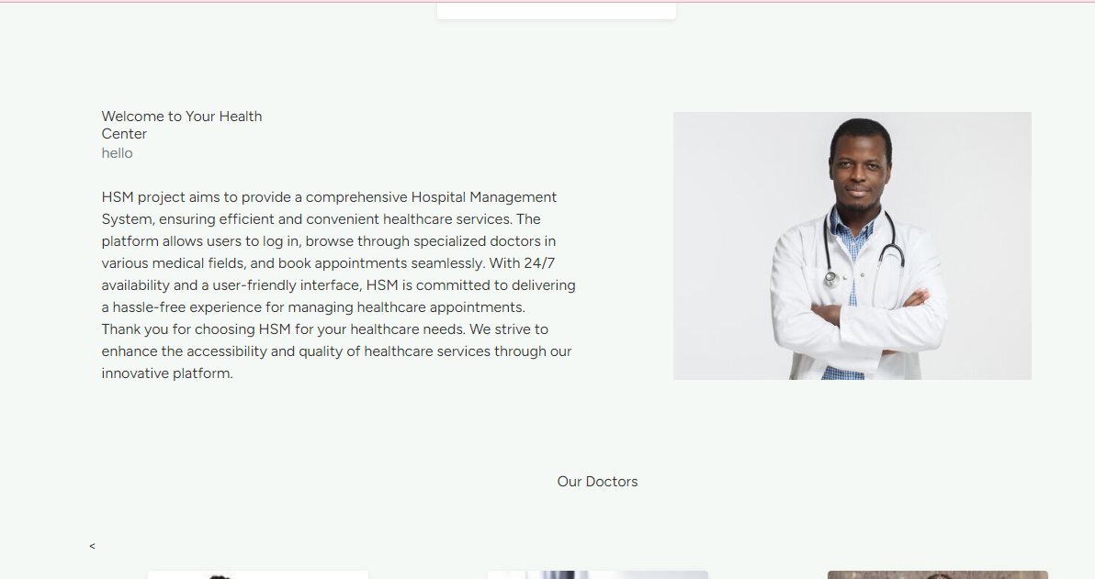

## Our doctors with pagination

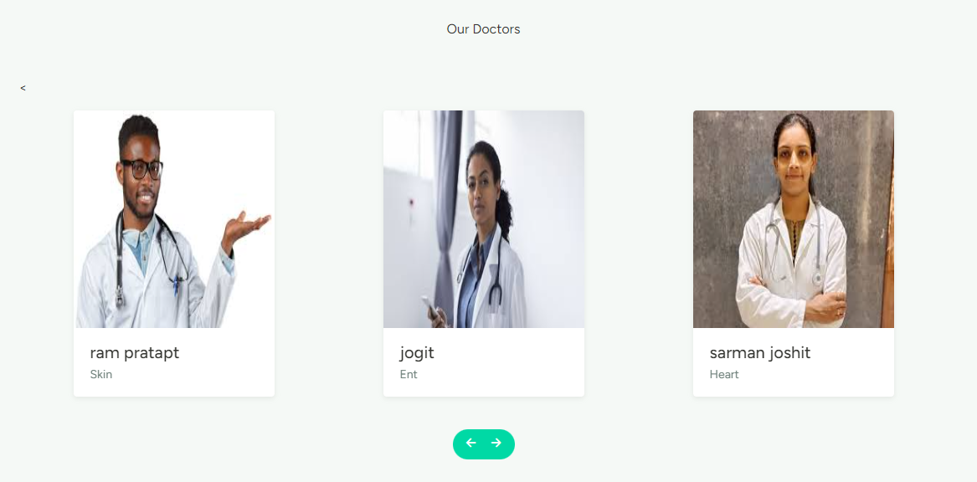

**Now let's move towards the admin section**

# Interface

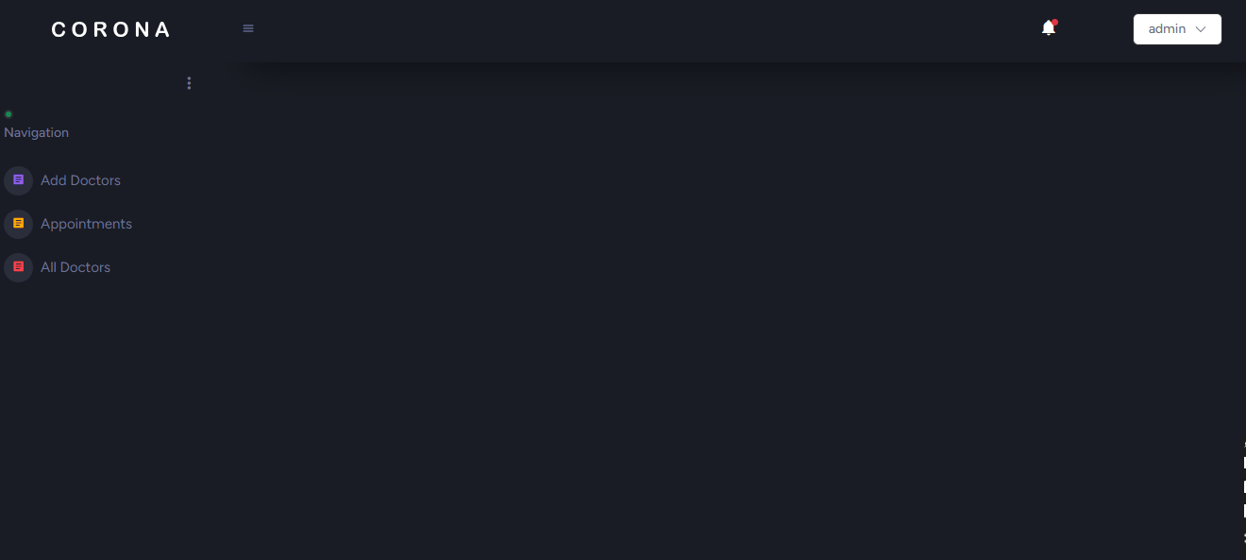

## Starts with adding a doctor

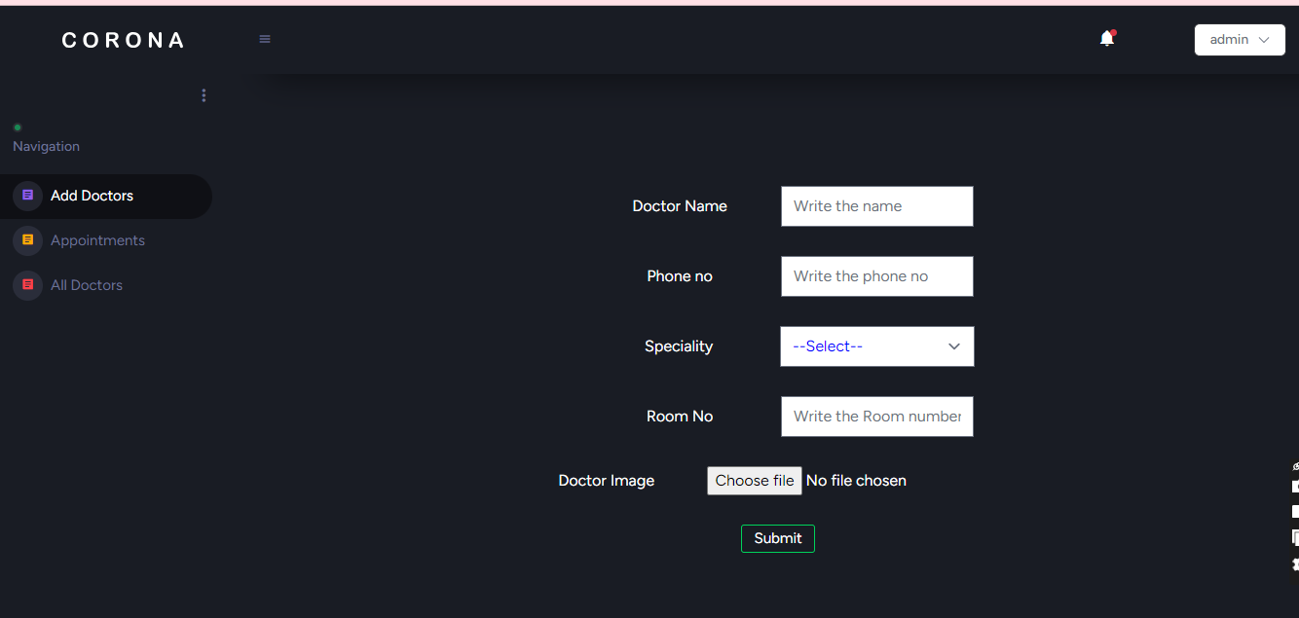

## Appointment with sort by functionality

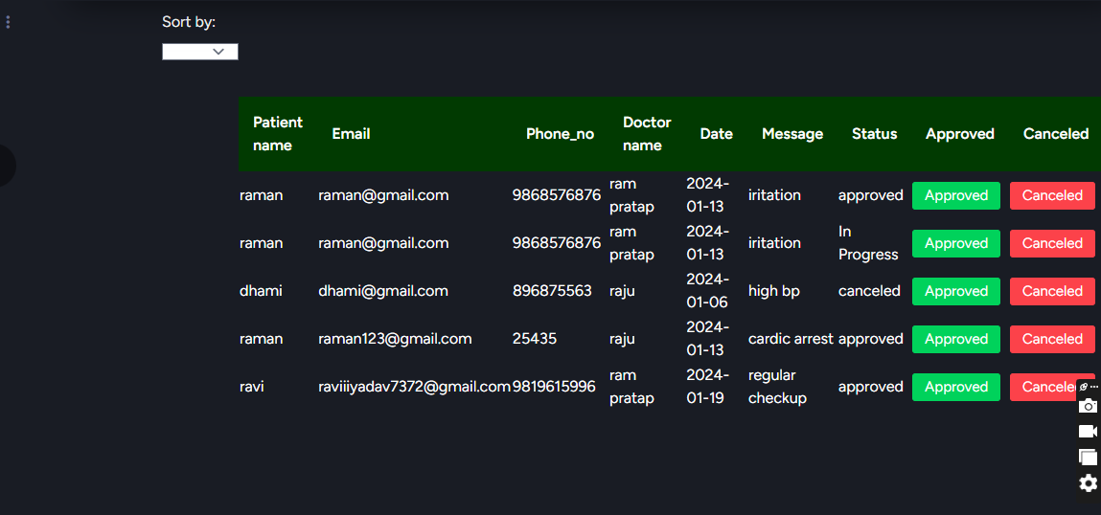

## All doctors with search functionality

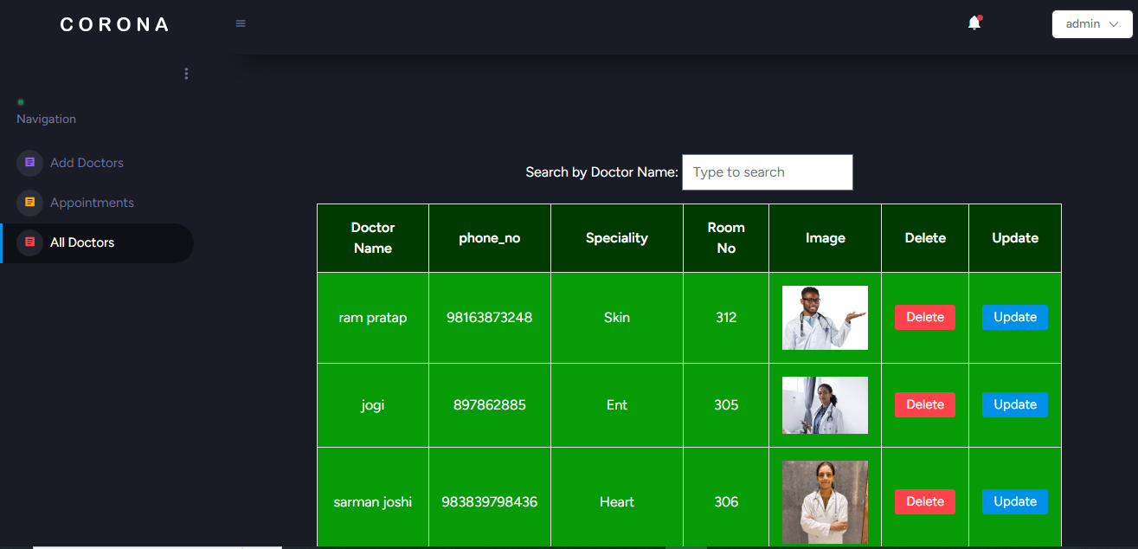

## Update doctor features

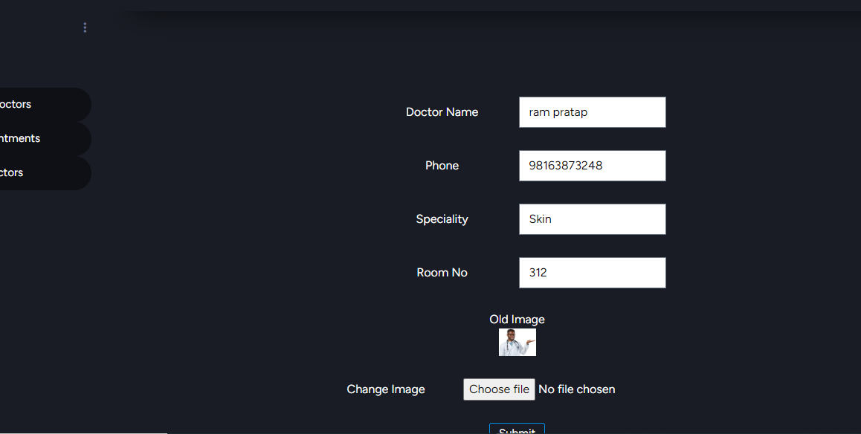

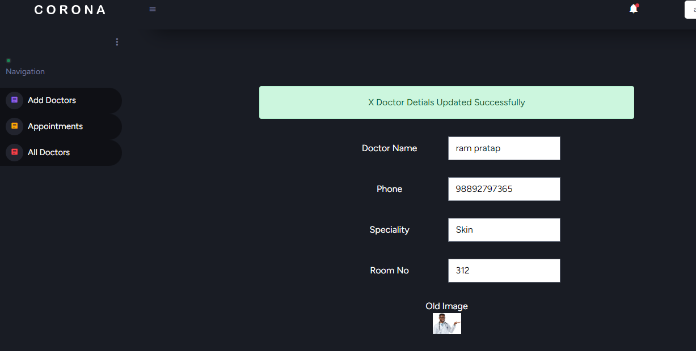

So we have done all the crude operations in the admin section and also in my appointment section of the user

# Code show

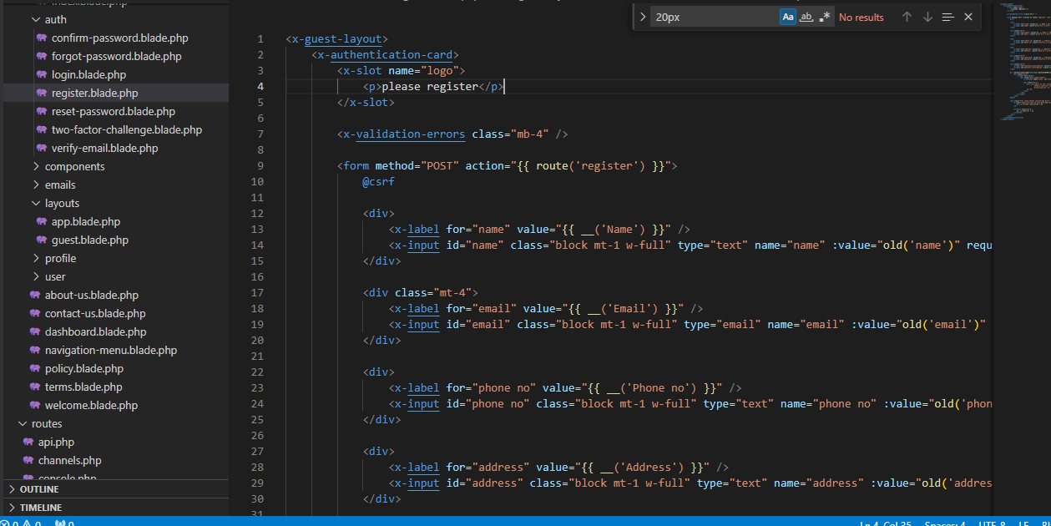

I have created a user folder inside which all the user php files are placed

Similarly, I have an admin folder in which all the admin-related php files are kept

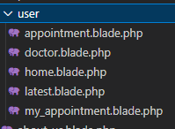

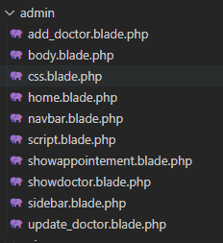

We have an asset folder in which all the necessary images that have been used as well html files

Let me show you the route and controller section

Route

Web.php

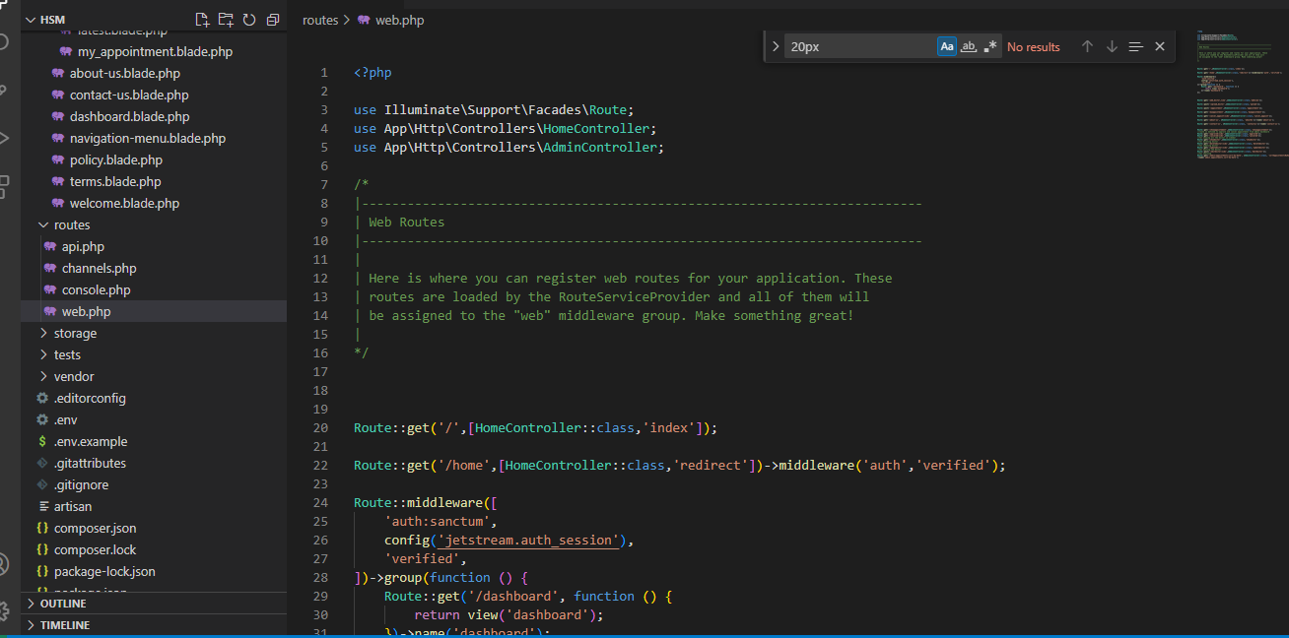

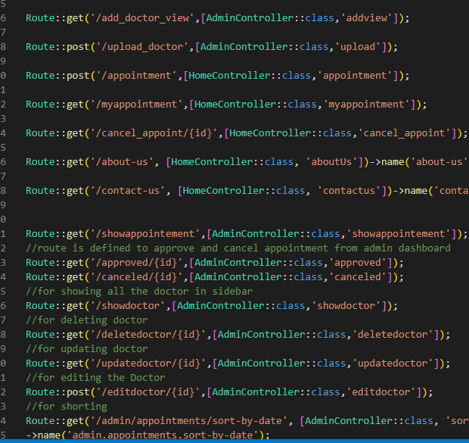

# Controllers

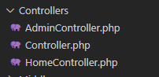

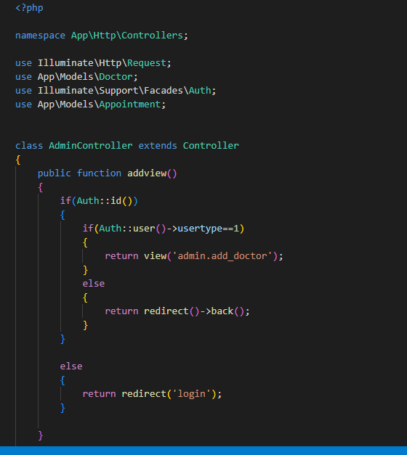

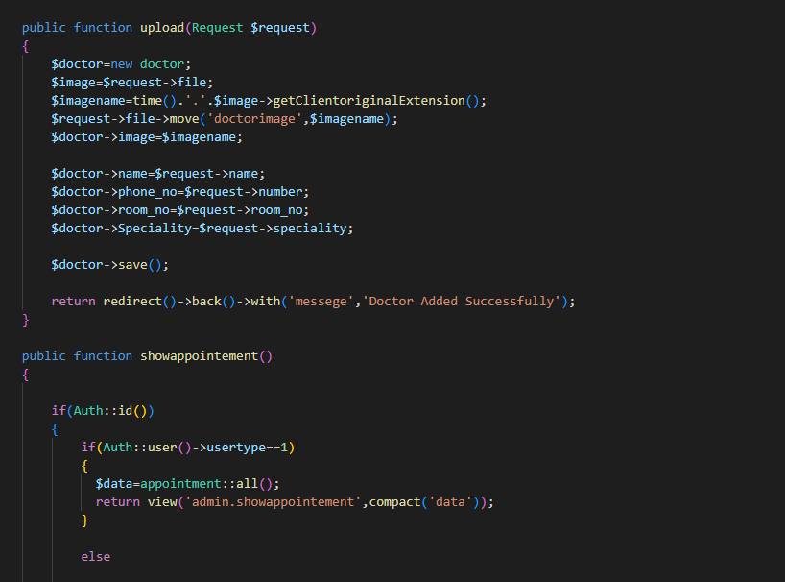

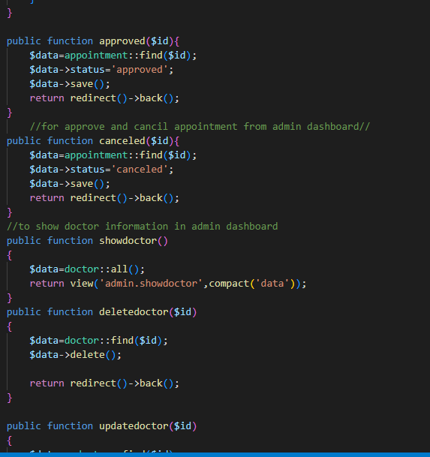

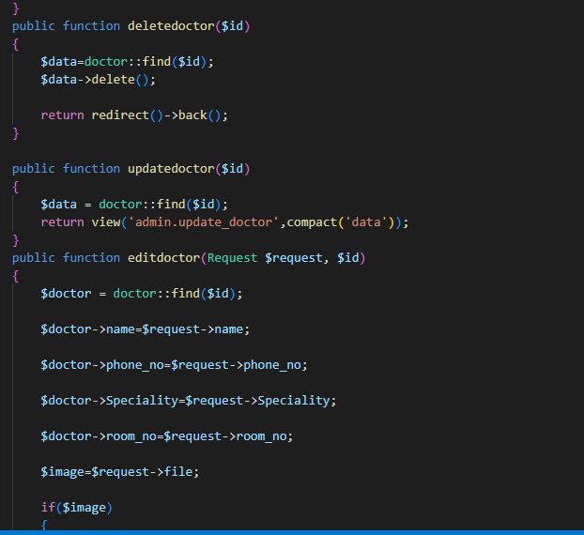

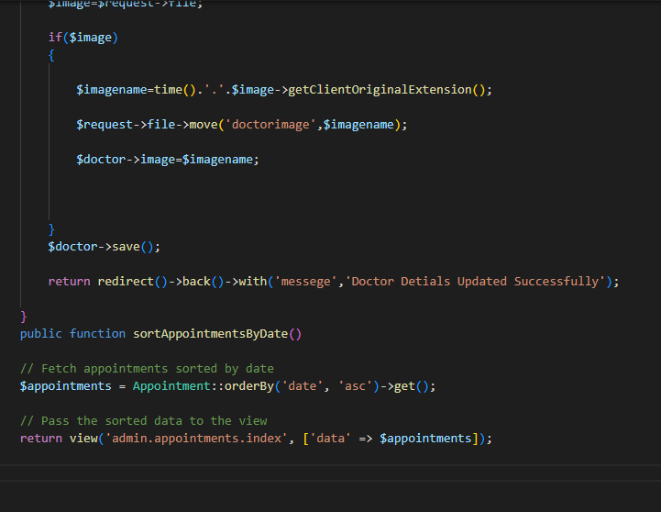

The controller handles all the requests from users through route

# Code from the home controller

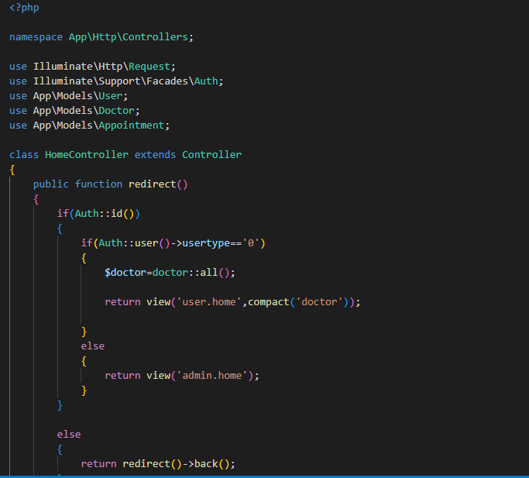

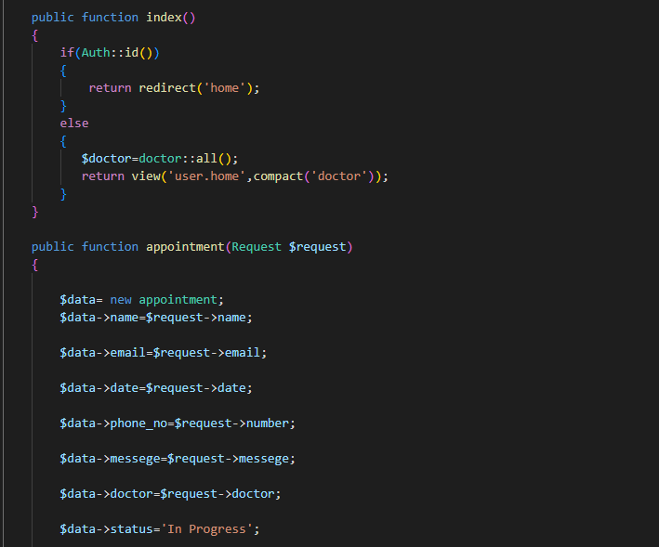

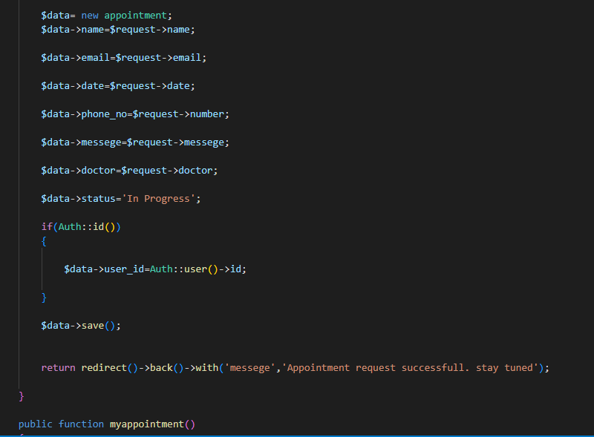

Now database section

# Database

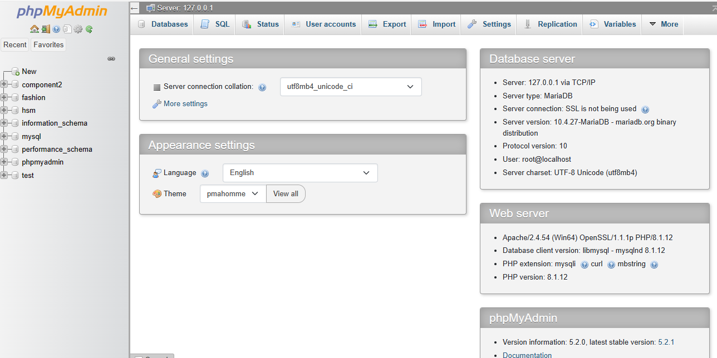

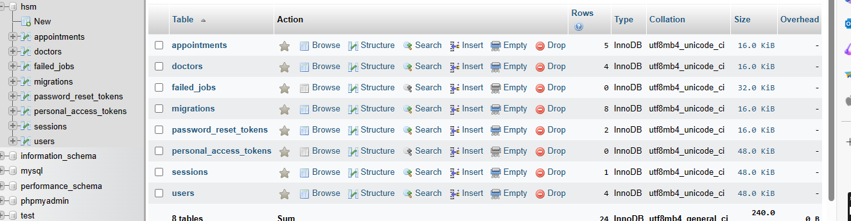

# Doctor table

